Chapter 5, Problem 36

For the circuit shown in Fig. 5.73, find the Thèvenin equivalent at terminals a-b. (Hint: To find R_{Th}, apply a current source i_{o} and calculate v_{o}.)

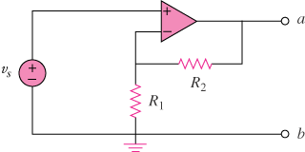

Figure 5.73
For Prob. 5.36.

